Distance in Labyrinth
We are given a labyrinth of size N x N. Some of its cells are empty (0) and some are full (x). We can move from an empty cell to another empty cell if they share common wall. Given a starting position (*) calculate and fill in the array the minimal distance from this position to any other cell in the array. Use "u" for all unreachable cells.
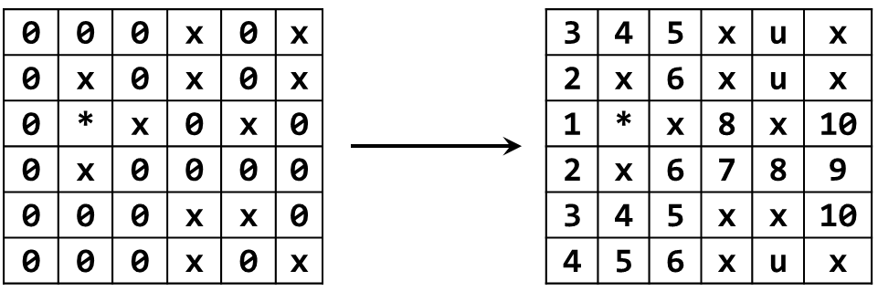
Input | Output
2  x0  *x | xu  *x
3  000  0*0  000 | 212  1*1  212
6  000x0x  0x0x0x  0*x0x0  0x0000  000xx0  000x0x | 345xux  2x6xux  1*x8x10  2x6789  345xx10  456xux

